**Mr. Visca’s: Calculus (sec 7.2)**

**Chpt 7 – Day 3: Areas in the Plane**

How can we find the area between these two curves??? Well, consider a very thin vertical strip.

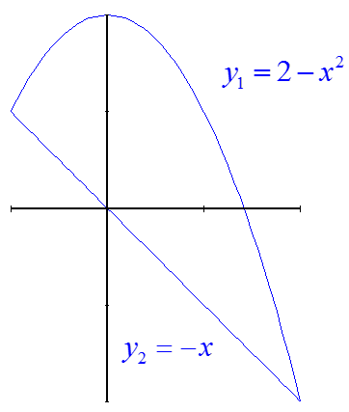

The length of the strip is:

________________________________

Since the width of the strip is a very   
small change in *x*, we could call it ______.

Since the strip is a long thin rectangle, the area of the strip is: length ∙ width = ________________________

If we add all the strips, we get: _______________________________

**The formula for the area between curves is:**

Always Remember: __________________________________

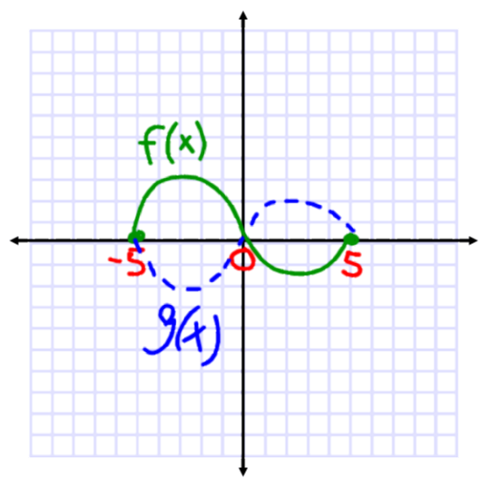

So what about...

Ex1. Find the area between the functions y = x - 2 and y = $\sqrt{x}$ from 0 ≤ x ≤ 4

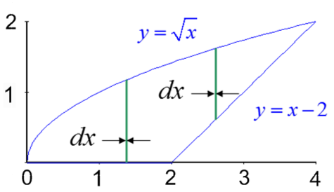

Ex2. Find the area between the functions y = x - 2 and y = $\sqrt{x}$ from 0 ≤ x ≤ 4 (now we are going to do this horizontally!)

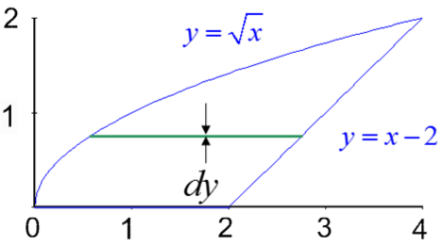

**General Strategy for Area Between Curves:**

1. Sketch the _______________
2. Decide on ______________ or _______________ strips. (Pick whichever is easier to write formulas for the length of the strip, and/or whichever will let you integrate __________________________.)
3. Write an expression for the area of the strip ________________. (If the width is dx, the length must be in terms of x. If the width is dy, the length must be in terms of y.
4. Find the __________ of integration. (If using dx, the limits are x values; if using dy, the limits are y values.)
5. ____________________ to find area.

**HW: section 7.1**

#s:1 – 6 all, 13, 17, 28, 30